Chapter No 3
COMPONENTS OF COMPUTER
OUTPUT DEVICES
REVISION:
Components of computer: Input, Output, CPU
Input: Any data which is entered to computer for processing.
Input Devices: The Hardware components to do input.
Key Board, Mouse, Track ball, touch pad, speakers etc are input devices
There are many other biometric devices used to do input like voice recognition and retina scanners.

WHAT IS OUTPUT?
An output is the data that has been processed in that form which is useful by user or machine for future processing. Output can be in two forms Soft Copy and Hard Copy. (Describe further)
WHAT ARE OUTPUT DEVICES?
Any hardware component used to show results after processing to any user and it use to send the results of processing to the user. Output can be text, Audio, Video & graphics.
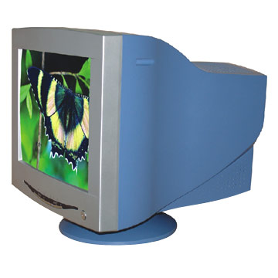
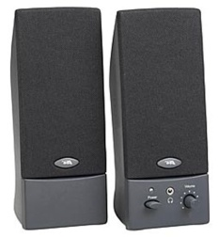
Examples
- Monitor
- Printer
- Plotter
- Projectors
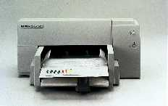
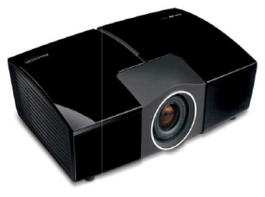
- Speakers
- Headphone etc

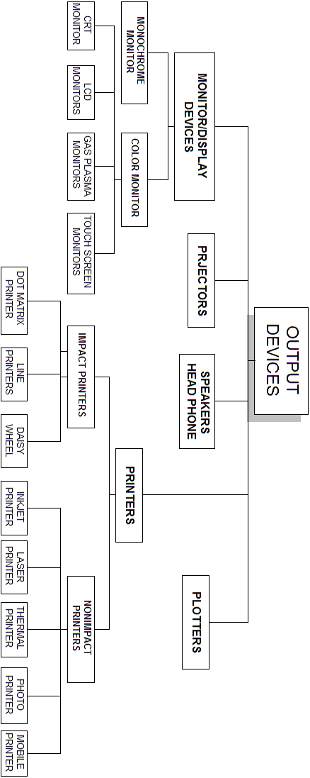

- MONITOR/DISPLAY DEVICES
Definition:
“Monitor or display devices are used to get output on screen. It is like small television and available in different sizes and specifications. The text which is displayed on screen is called softcopy (as defined above)”
TYPES OF MONITOR
There are majorly two type of monitor according to its specification. These are
- Monochrome monitor
- Color monitor
  - MONOCHROME MONITOR
Monochrome monitor is based on a single color that can be white, blue, black or gray etc. these type of monitors is same like the old mobile phones which have a single color in back ground with black text in display. That is very much useful in these devices where we need simple display. Like some ATM machines, mobile phones, specific digital devices like PDA, pagers etc
  - COLOR MONITOR
Color monitor is such monitor which is based on colors as its name implies. Today mostly monitor are based on color display rather it is flat panel or tube based monitors. The basic colors in that monitors are three which are RGB stands for Red, Blue, Green by these basic colors a monitor can generate many other colors by the combination of these basic colors.

1.2) COLOR MONITORS

FEATURES & SPECIFICATIONS
When we talked about monitor specification and features then there are several factors which we have to keep in our view. Whenever we want to buy monitor we have to keep these features in our view, defined as under:

- Color
- Size
- Resolution
- Pixel Pitch
- Refresher rate

COLOR

Monitor can view different colors specifically some monitor can view only single color in its background and black text on its screen these monitors are very simple (as defined above) is called monochrome monitors.

Monitor work with three basic colors and by these three colors it makes different colors in by combinations. These colors are RGB, mean Red, Green and Blue. By combinations it can make 256 colors. More colors more exclusive display.

SIZE
Like television monitor is also available in different sizes. The size started from15 inches to 22 inches monitor.
RESOLUTION
An important characteristic of all monitor screens is its resolution. The screen is divided in to vertical and horizontal lines and intersecting of these lines make many small boxes and these boxes in used to display images, called pixels
Pixel

Each point of light on the screen is called a pixel. The resolution of a screen is the number of pixels that the screen can display. This is given as the number of pixels across (horizontal resolution) by the number of pixels down (vertical resolution). For example, 800 x 600. The greater the resolution the better. Modern screens can display 1024 X 768 or better.
PIXEL PITCH
The distance between two pixels on screen is called pixel pitch. it is also an important feature of monitor. If we want to view clear images on monitors it must have less distance between pixels. That pixel pitch is also called dot pitch. It is measured in millimeters.
REFERESHER RATE
Every monitor has a electric gun behind screen. That gun omits light and makes images to the screen. Refresher rate is that time which gun used to regenerate new image on screen. Refresher rate is measured in hertz .it is also an important feature for better quality of display. , this is the number of times the image is refreshed every second. A low refresh rate makes the image appear to flicker. You need a refresh rate of at least 72 Hz (72 times a second) to avoid the appearance of flicker.

1.2.1) CRT MONITORS
The cathode ray tube (CRT) type monitors and makes use of the same technology as a television screen. A beam of electronics is fired from an electronic gun at the back of the tube. This strikes the front of the tube which is covered in a phosphorescent material which glows when struck by electrons. Between the electron gun and the screen the beam is modulated by a signal to produce the image you see on the screen.
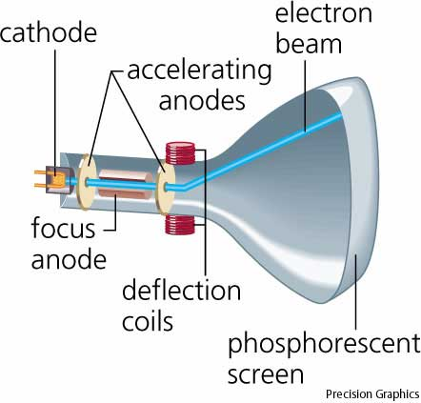

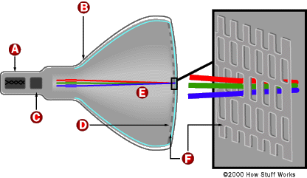

1.2.2) LCD MONITORS
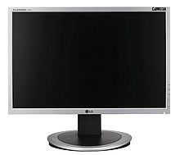
The LCD monitors bring lots of advantages when compared to the CRT ones. The first advantage which is also the most obvious one is the fact that the LCD monitors are smaller and have a smaller weight than the CRT monitors.
The LCD monitors can be placed on the table and they use far less space than the CRT monitors. This is a great advantage. The picture quality of the LCD monitors will be increased as well which means that the movies will be displayed in a better quality and the games will have better colors, and so on.
In most of the cases the LCD monitors will have certain features which provide additional functionality. Some of the LCD monitors have USB hubs, HDMI input, TV tuner, and so on. The TV tuner is very important because you can use the computer for watching TV. The aspect ratio of the monitors has changed.
The resolution will be highly influenced by the monitor size. The larger the size of the monitor is the larger resolutions it will have. If you buy the biggest monitor that you can buy because the experience of watching movies or playing games on it will be much more enjoyable. This was my info on the LCD computer monitors.
1.2.3) GAS PLASMAMONITORS
A gas-plasma display works by sandwiching neon gas between two plates. Each plate is coated with a conductive print. The print on one plate contains vertical conductive lines and the other plate has horizontal lines. Together, the two plates form a grid.
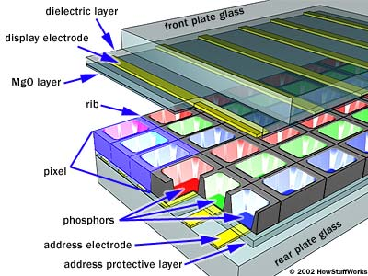
When electric current is passed through a horizontal and vertical line, the gas at the intersection glows, creating a point of light, or pixel. You can think of a gas-plasma display as a collection of very small neon bulbs. Images on gas-plasma displays generally appear as orange objects on top of a black background.

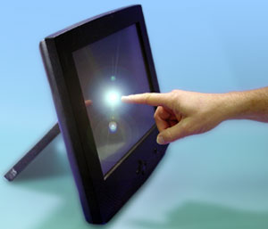
1.2.4) TOUCH SCREEN MONITORS
These monitors use touching of the screen as an input method. Items can be selected or moved with a finger, and finger gestures may be used to convey commands. The screen will need frequent cleaning due to image degradation from fingerprints.

- PRINTERS
The second most common form of computer output is printed documents. Although a computer can operate perfectly without a printer, it is certainly helpful to the user to have one. People often prefer to get printouts of the work they have done rather than to look at it on the screen it is considered a form of hard copy.
Types:
Printer has majorly two types.
- Impact printers
- Non impact printers

2.1) IMPACT PRINTERS
Impact printers produce output by striking a ribbon with a hammer. When the ribbon is hit a mark is made on the paper behind it. If carbon paper is put into the printer then an impact printer can print more than one copy of a document at a time. This feature is often used by companies when they print invoices, bills etc. Because of the hammering action impact printers are noisy when they are printing.

2.1.1) DOT MATRIX PRINTERS
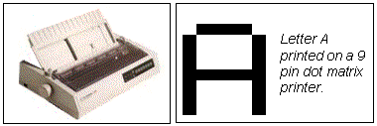
Dot matrix printers produce an image by hammering a column of 9 or 24 pins against a ribbon. Characters are produced as the print head (which contains the pins) moves across the page.

Dot matrix printers are cheap to purchase and have low operating costs. Most can run in either draft mode (quick but very low quality) or Near Letter Quality mode (slower but better quality). The disadvantages of dot matrix printers are that the output quality is poor, it takes a long time to print a document and the noise can be annoying.

2.1.2) DAISY WHEEL PRINTERS
Daisy wheel printers are rarely used any more. A daisy wheel printer hammers character stamps (like those on typewriters) against a ribbon to produce high quality text output. The character patterns are all arranged around the edge of a wheel.
When a letter is to be printed the wheel rotates so that the correct letter is against the ribbon. A hammer then hits the letter against the ribbon to print it on the paper. Daisy wheel printers are very slow and noisy. It is not possible to print graphics using a daisy wheel printer.

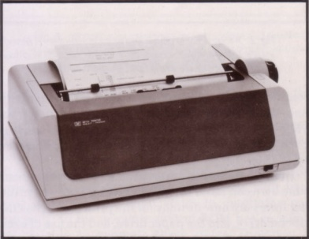

2.1.3) LINE PRINTERS
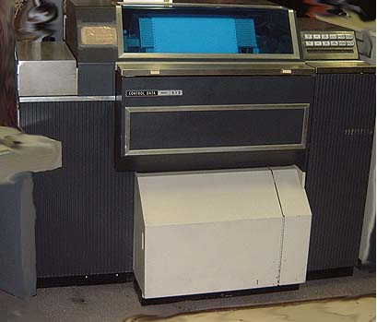
Dot matrix and daisy wheel printers both print only one character at a time. For that reason they are called Character Printers. In contrast a line printer prints a whole line (typically 80 or 132 characters) of text at a time. These printers are very fast. They are expensive to buy and are used when high volumes of output are required. Example applications include printing telephone bills or bank statements. The main drawback to line printers is that they can produce only text--no graphics

2.2) NON IMPACT PRINTERS
Non-impact printers do not produce images by hammering pins or characters against the paper. Because there is no hammering action non-impact printers are very quiet but cannot print multiple copies using carbon paper.
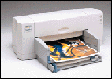
2.2.1) INK JET PRINTERS
Ink jet printers are the most popular type of printer for use at home or in a small business. This is because they are relatively cheap to purchase and can print in color. Ink jet printers generate output by squirting tiny jets of ink at the paper to be printed on.
A column of ink jets in the print head moves across the page squirting dots onto the page to make the image.
Typically ink jet printers can produce 360 or 720 dots per inch (dpi) but these dots are larger than those that a laser printer makes so the quality although very good is not quite as perfect. Ink-jet printers can work in black and white or color. Black and white versions cost from Rs 5,000 and color ones from about 10,000. They are slower than laser printers (3ppm) and cost slightly more to run.
2.2.2) LASER PRINTERSS
Laser printers are called Page Printers because they print a whole page at a time. A laser beam is used to draw the image to be printed onto a light sensitive Drum. After the image has been drawn on the drum a fine powder ink called Toner is put onto it. The toner only sticks where the laser has drawn the image. The paper then passes over the drum and the toner is transferred onto the paper.
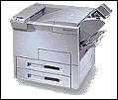

Laser printers produce very high quality output, are very quiet and very fast. Typical home laser printers can print 8 pages per minute (ppm). Some industrial versions print over 40ppm and can print on both sides of a piece of paper at the same time. The main disadvantage of this type of printer is the high cost. Small laser printers cost from Rs 3,000 to buy and are more usually about Rs 8,000. Color laser printers cost Rs 30,000+. Running costs are higher than impact printers but lower than most ink jet printers.
2.2.3) THERMAL PRINTERS
Thermal printers are no longer used as printers for PCs. They are however still used in some computer control systems, tills and in many fax machines. These printers print on special heat sensitive paper which is expensive. The image is produced from small dots which are made on the paper by heating it up. The quality is reasonable and graphics can be printed.
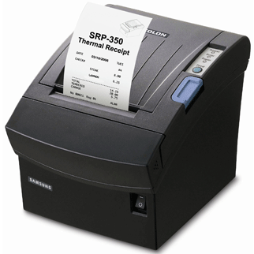

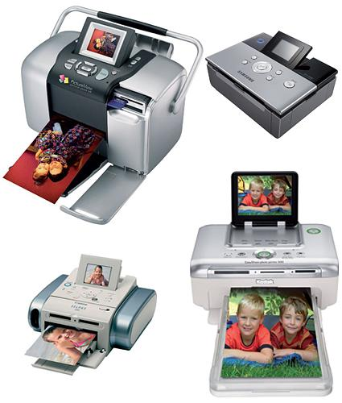
2.2.4) PHOTO PRINTERS
A printer specialized for smaller prints such as 4x6" and 5x7". When first introduced in the mid-1990s, photo printers used dye sublimation for high quality printing because inkjet printing was not quite up to par. Since then, inkjet technology has greatly improved, and most photo printers are inkjets. Epson, Canon and HP are major players in this market

2.2.5) MOBILE PRINTERS
A monitor is portable and we can take it any where we want. Mobile printers are making it easier and faster for us to free our trapped images from their digital prisons -- all without using a drop of ink.
Without ink, it can be dramatically smaller than their predecessors, making them more convenient and even portable. It is said to be "mobile" because it receive wireless signals to print. However, with inkless printing technology, printers can be mobile in a more radical way -- you can carry it around in a pocket or a purse, just like a cell phone

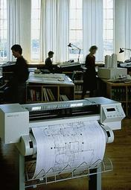
- PLOTTERS
A plotter, like a printer, produces hard-copy output. Plotters, which produce high-quality color graphics, are usually categorized by whether they use pens or electrostatic charges to create images. A continuous-curve plotter is used to draw maps from stored data. Computer-generated maps can be retrieved and plotted or used to show changes over time. Plotters are generally more expensive than printers, ranging from about 100,000 to $750,000 (or even more).

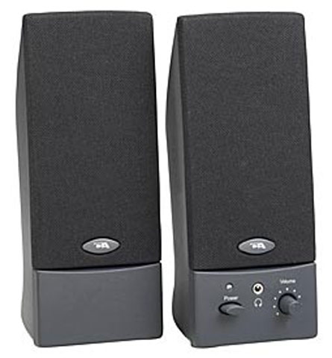
- SPEAKERS/ HEADPHONE
Speakers and headset is used to get audio output. A system's speaker is the component that takes the electronic signal stored on things like CDs, tapes and DVDs and turns it back into actual sound that we can hear. In any sound system, ultimate quality depends on the speakers. The best recording, encoded on the most advanced storage device and played by a top-of-the-line deck and amplifier, will sound awful if the system is hooked up to poor speakers.

- MULTIMEDIA/PROJECTORS
A Digital Projector/Multimedia is an electo-optical machine which converts image data from a computer or video source to a bright image which is then imaged on a distant wall or screen using a lens system. The cost of a device is not only determined by its resolution, but also by its brightness. The projector serves the following purposes:
- Visualization of data stored in a computer for presentations
- Demonstration of program products for a large number of prospective customers
- The projector replaces the white board as well as written documents.
- Watching moving images from a video tape player or digital video disk player.
- Digital projectors may also be built into cabinets which use a rear projection screen to form a single unified display device, now popular for "home theater" applications.
